

Phase 2 Project: Cryptography
Suhaila Alfalasi
Fatima Rabiu
Rania Kanaan
RIT Dubai
Dr. Wesam Almobaidenn
November 17, 2024

Table Of Contents
PHASE 1 3
Introduction 3
Objectives: 4
Pseudo Code: 5
Description of Algorithm: 10
Implementation Specifications: 13
Appendix: 16
Summary: 20
PHASE 2 21
Introduction 21
Objectives 21
Methodology 21
Encryption Algorithm Overview 21
Frequency Analysis Techniques 21
Results and Analysis 21
Single-Letter Frequency Analysis 21
Diagram Frequency Analysis 21
Trigram Frequency Analysis 21
Word Validation 21
Attack Explanation 21
Recommendations for Security Improvement 21
Conclusion 21
Appendix 21
References 22

PHASE 1

Introduction
Cryptography is a mathematical and creative field that depends on receiving information, sentences or data that can be read by all people, then this data is encrypted and made difficult to read and decipher except by the competent authorities who have knowledge about how to decrypt. [1] Encryption is considered one of the most important techniques for protecting information from hacking because it contains system security and secret sub-storage, so encryption ensures the confidentiality of information and prevents tampering with it and forgery, as well as, Encryption and decryption algorithm's security depends on the algorithm. [2]
Furthermore, Ciphers make text communication a mystery to anyone who might try to hack or intercept it. It is also said that Julius Caesar used these ciphers to be able to communicate with his army during war. He is considered one of the first people to use ciphers to protect messages. Through the cipher he used, he decided to move each letter three places below the alphabetical letters in the message so that this would be his standard algorithm (The Caesar Cipher). [3]

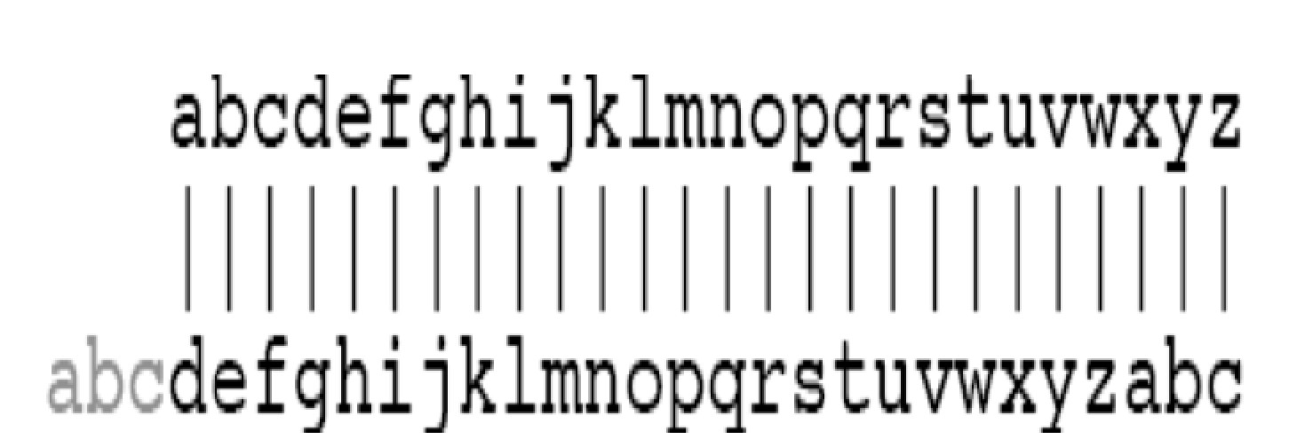
Fig 1: Cesar Cipher working [3]

Objectives:
The aim of this project is for students to understand how encryption algorithms work, through an interface that details the steps required to implement such algorithms. The project also teaches the importance of the process of encryption and decryption for hiding data using mono-alphabetic and Caesar ciphers, making it harder for attackers to crack the code. By the end of this project, a decryption algorithm will be created that matches a specific encryption method, with a focus on classical ciphers, such as monoalphabetic ciphers and Caesar ciphers.

Pseudo Code:
DEFINE substitutionTable as 26 characters = { 'h', 'i', 'l', 'w', 'm', 'k', 'b', 'd', 'p', 'c', 'v', 'a', 'z', 'u', 's', 'j', 'g', 'r', 'y', 'n', 'q', 'x', 'o', 'f', 't', 'e' }

FUNCTION findIndex(character)
IF the inputted character is an not alphabetic
RETURN -1
END IF
RETURN the character by converting it to lowercase and find its index in the alphabet
END FUNCTION

FUNCTION caesarShift(letter, shift)
IF the inputted letter is not an alphabetic,
RETURN the input as it is
END IF
⁠SET base to check whether the letter is an lowercase or uppercase
RETURN the letter by its new shifted letter position
END FUNCTION

FUNCTION caesarUnshift(letter, shift)
IF the inputted letter is not an alphabetic,
RETURN the input as it is
END IF
⁠⁠SET base to check whether the letter is an lowercase or uppercase
RETURN the letter by its original shifted letter position
END FUNCTION

FUNCTION encrypt(plainText, cipherText, logFile)
GET the size length characters of the plaintext
SET the ⁠lastSubstitutionIndex ⁠equal to zero
SET the letter_count ⁠equal to zero
FOR each character in the plaintext file:
IF its an alphabetic character THEN
IF the alphabetic character is in the 6th position THEN
FIND its index and substitute it using the substitutionTable
IF the index is is between 0 to 26 THEN
SUBSTITUTE that character using substitutionTable
UPDATE the⁠ lastSubstitutionIndex ⁠
DISPLAY substitution shift of original to the new character
ELSE:
Leave the non-alphabetic inputted character as it is
END IF
ELSE:
SET the shift to the lastSubstituationIndex
Start the Caesar shift for the rest 5 characters
DISPLAY the Caesar Cipher shift
END IF
INCREMENT the count of the character
ELSE:
Leave the non-alphabetic inputted character as it is
END IF
WRITE for each character the is encrypted inside the log file
END FOR
TERMINATE the⁠ cipherText ⁠after the shifting all characters
END FUNCTION

FUNCTION decrypt(cipherText, plainText, logFile)
GET the size length characters of the ciphertext
SET the ⁠lastSubstitutionIndex ⁠equal to zero
SET the letter_count ⁠equal to zero

FOR each character in the ciphertext file:
IF its an alphabetic character THEN
IF the alphabetic character is in the 6th position THEN
FOR each letter in ⁠ substitutionTable ⁠:
IF the character is found in the substitution table THEN
GET its original letter
UPDATE the ⁠ lastSubstitutionIndex ⁠
DISPLAY the shift to its original characters
BREAK the loop
END IF
END FOR
ELSE:
SET the shift to the lastSubstituationIndex
Start the reversing the Caesar shift for the rest 5 characters
DISPLAY the reversed Caesar Cipher shift
END IF
INCREMENT the count of the character
ELSE:
Leave the non-alphabetic inputted character as it is
END IF
WRITE for each character the is decrypted inside the log file
END FOR
⁠TERMINATE the⁠ decrypted text ⁠after reserse shifting all characters
END FUNCTION

MAIN Function
DECLARE plainTextFile, cipherTextFile, decryptedTextFile, logFile
DECLARE the plainText, cipherText, and the decryptedText as character equal to null
SET the bufsize equal to zero
SET the choice equal to zero

WHILE TRUE DO
DISPLAY "Menu:"
DISPLAY "1. Enter text and save to plaintext.txt"
DISPLAY "2. Encrypt text from plaintext.txt"
DISPLAY "3. Decrypt text from ciphertext.txt"
DISPLAY "0. Exit"
DISPLAY "Enter your choice: "
READ choice that the user inputted

SWITCH (choice)
CASE 1:
OPEN "plaintext.txt" to start writing inside the plainTextFile
IF plainTextFile cannot be opened THEN
DISPLAY "Error opening plain text file"
EXIT PROGRAM
ENDIF

DISPLAY "Enter text to save to plaintext.txt: "
READ the text that the user have inputted
WRITE the user input to the plainTextFile
CLOSE plainTextFile
DISPLAY "Text saved to plaintext.txt"
BREAK

CASE 2:
OPEN "plaintext.txt" to read the user input text
IF plainTextFile cannot be opened THEN
PRINT "Error: plaintext.txt does not exist."
BREAK
ENDIF
GET the fseek function to determine the size of the plainTextFile
SET plaintextSize equal to the size of the plainTextFile in bytes
GET the fseek function to point at the beginning to start reading
SET painText to store the file content in the dynamic allocated memory
GET the fseek function to read the files content into the memory
SET an plainText terminator to stop storing at the end of the file
FCLOSE plainTextFile

SET ciphertext to dynamic allocated memory to store the encrypted text
OPEN "ciphertext.txt" to store the encrypted text
OPEN "log.txt" to start storing the encryption process
IF either the ciphertext nor the log file cant be opened THEN
DISPLAY "Error opening output files"
EXIT PROGRAM
ENDIF
DISPLAY "Encryption Process:"
CALL encrypt(plainText, cipherText, logFile)
WRITE the result of the encryption in cipherText
FCLOSE the cipherTextFile
FCLOSE the logFile
SET free function for cipherText
DISPLAY "Encryption complete. Check ciphertext.txt and log.txt for details."
BREAK

CASE 3:
OPEN "ciphertext.txt" to read the encrypted text
IF cipherTextFile cant be openTHEN
DISPLAY "Error: ciphertext.txt does not exist."
BREAK
ENDIF
GET the fseek function to determine the size of the cipherTextFile
SET cipherTextSize equal to the size of the cipherTextFile in bytes
GET the fseek function to point at the beginning to start reading
SET cipherText to store the file content in the dynamic allocated memory
GET the fseek function to read the files content into the memory
SET an cipherText terminator to stop storing at the end of the file
FCLOSE cipherTextFile

SET decryptedText to store the file content in the dynamic allocated memory
OPEN "decrypted.txt" to start writing into decryptedTextFile
OPEN "log.txt" to starting adding the decryption process
IF either the decryptedText nor the log file cant be opened THEN
DISPLAY "Error opening output files"
EXIT PROGRAM
ENDIF
DISPLAY "Decryption Process:"
CALL decrypt(cipherText, decryptedText, logFile)
WRITE the decrypted text into decryptedTextFile
FCLOSE decryptedTextFile
FCLOSE logFile
SET free function for decryptedText
DISPLAY "Decryption complete. Check decrypted.txt and log.txt for details."
BREAK

CASE 0:
DISPLAY "Exiting program."
SET free function for plainText
EXIT PROGRAM

DEFAULT:
DISPLAY "Invalid choice. Please try again."
BREAK
END SWITCH
END WHILE
END MAIN

Description of Algorithm:
This code compromises both encryption and decryption algorithms.. The encryption algorithm makes use of the plain text file in saved (.txt) when the user inputs a text for example in this case one that contains the phrase ‘if we had anything confidential to say’ in the same folder as the c code and uses it to change it into cipher text with the help of the substitution and caesar cipher techniques to hide the content of the message.
Encryption
Substitution Cipher:
In the substitution cipher uses the sixth letter of the alphabet and replaces it with the corresponding letter from the given table.To explain further, if are going to encrypt ‘if we had anything’ , we will count ‘i’ as the first letter then count down to ‘a’ as the 6th letter.The ‘a’ in ‘anything’ in the table is replaced by ‘h’ , the rest remain the same till the next 6th letter. while the next letter is ‘n’ in ‘confidential’ , which is replaced by ‘u’ and so it goes.
Spaces are not changed in this process.

Caesar cipher method:
This happens after substitution. The Caesar cipher method shifts the other letters left based on their numbered position,this is done to the next 5 letters after each substitution. For example, with the first substitution example given above being ‘a’ to ‘h’, it gives the caesar shift 0 , as the letter ‘a’ is 0 in the alphabets, which will also be the next shift number (0) for the next five letters.as a result, ‘n’ , ‘y’, ‘t’, ‘h’, ‘i’ all stay the same. However if we do the substitution ‘n’ turns into ‘u’ as ‘n’ is the 13th letter so shift= 13, where by ‘f’ turns into ‘s’, ‘i’ turns into ‘v’ and so on for the rest of the next 3 letters.
Spaces are not changed in this process.
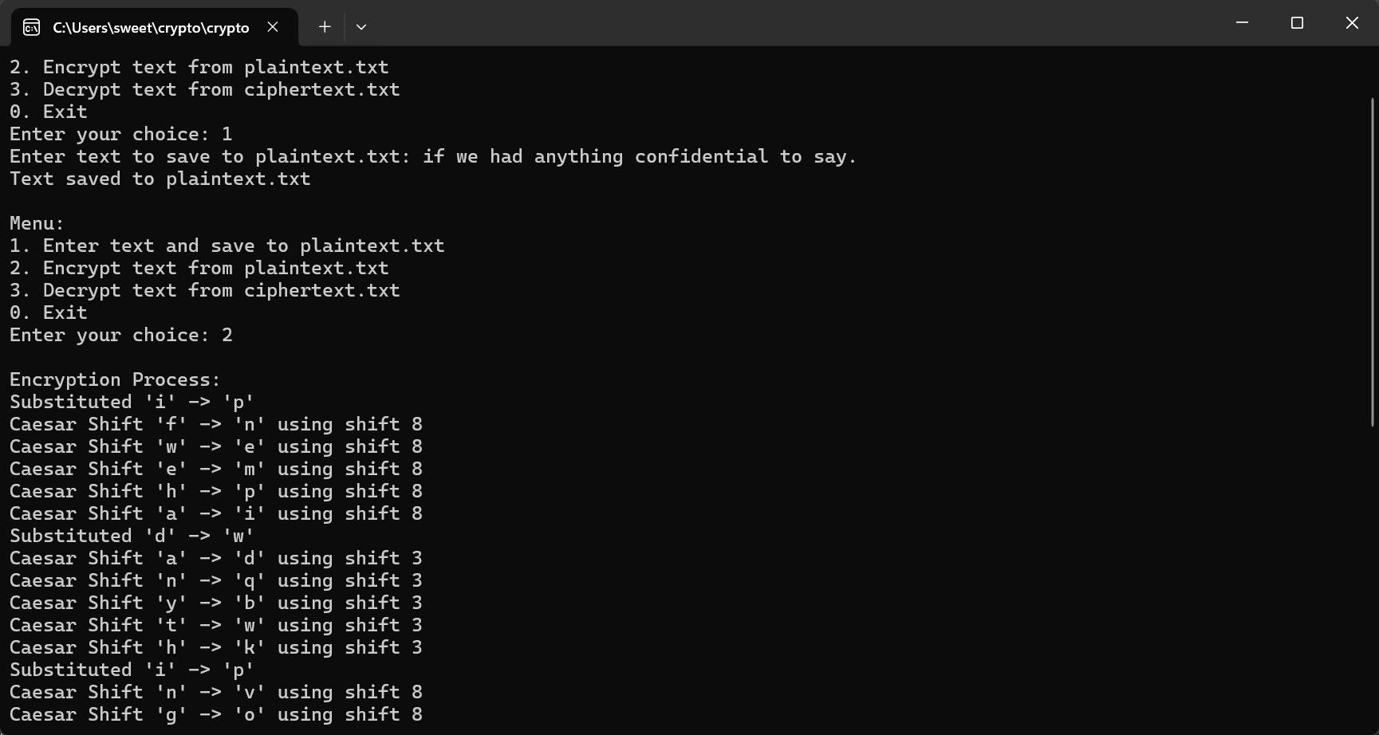
Decryption:
The decryption process does the exact opposite of the encryption. For example in decryption when it comes to substituting the sixth letter ‘h’ in the cipher text that we knew previously as ‘a’ , the same way we reserve the other substitutions in order of their positions in the ciphertext. For the Caesar shift, we unshift it, in other words after every substitution, the next 5 use the same shift number previously in the encryption to move back.

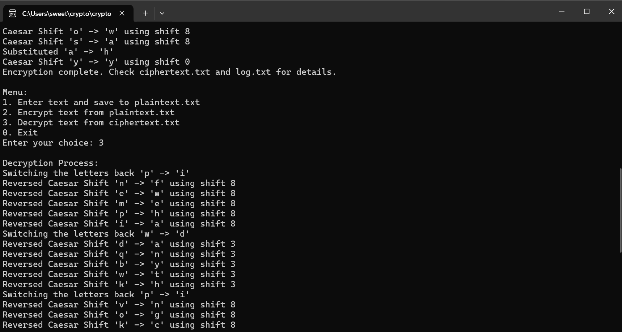
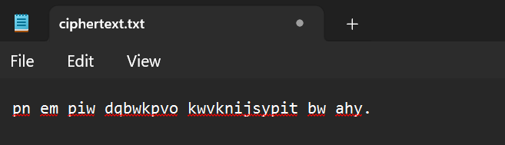

Implementation Specifications:
- Language and Libraries used:
- The programming language used in this project is C language.
- The libraries used are stdio.h, stdlib.h, string.h, and ctype.h.
  - The stdio.h is used for printing the outputs in the terminal and file handling such as opening and closing the files
  - The stdlib.h is a library used for error handling such as ‘perror’
  - The string.h is used for the characters operations such as ‘strlen’
  - The ctype.h is used for character handling such as the ‘islower’
- The Substitution Table:
- The mono-alphabetic substitution table is 26 letters not placed in the right alphabetical order and it is not repeated, which will be placed for every 6 characters in the sentence. The substitution will be based on the alphabetical order corresponding to the mapped substitution table.
- The Cipher Technique Used:
- Mono-alphabetic substitution table: Is mapping to the letter from the alphabetical order to its corresponding substitution table.
- Caesar Cipher: is shifting based on the previous letter that has been mapped using the mono-aplabetical substitution.
- Reversing the Caesar Cipher: is when do the decryption process of reversing the caesar cipher substitution of the previous letter back to its original letter.
- Encryption Process:
- Is the entered characters in the file called ‘Plain text’ that will loop to each character in that plaintext and substituted based on the previous character position into a file called the ‘Cipher text’
- Decryption Process:
- Is the process of looping in the file ‘Cipher text’ that will substitute the character back to its original character into the file of the ‘decryption file’ .

6. File I/O part:
- First Input Files:
plaintext.txt: which contains the plain text to be encrypted.

- Second Output Files:
ciphertext.txt: Stores the result of the text that has been encrypted.
decrypted.txt: Stores the text that has been decrypted after finishing the cipher text.
log.txt: Logs the encryption and decryption steps for verification Each transformation from plain text to cipher text, and cipher text to plain text is recorded.

7. Error Handling:
- The program prints an error message after checking if input/output files are successfully opened.

8. Program Flow:
- The main function holds the entire process:
it reads from a file the plain text. then it calls the encryption function to encrypt the text then writes the result to the cipher text file. after that, it calls the decryption function to decrypt the text and check if it matches the original. All these steps are logged in log.txt for transparency and debugging.

9. Constraints:
- The program handles for the plain text and encrypted text up to 256 characters. The only characters that are encrypted are the alphabetic ones; non-alphabetic characters remain unchanged.

Appendix:
#include <stdio.h>
#include <stdlib.h>
#include <string.h>
#include <ctype.h>
// Substitution table - Mono-alphabetic initial configuration (shared key)
char substitutionTable[26] = {
'h', 'i', 'l', 'w', 'm', 'k', 'b', 'd',
'p', 'c', 'v', 'a', 'z', 'u', 's', 'j',
'g', 'r', 'y', 'n', 'q', 'x', 'o', 'f',
't', 'e'
};
// Find the index of a character in the alphabet
int findIndex(char ch) {
if (!isalpha(ch)) return -1; // Return -1 for non-alphabetic characters
return tolower(ch) - 'a';
}
// Caesar shift
char caesarShift(char letter, int shift) {
if (!isalpha(letter)) return letter; // If not a letter, return unchanged
char base = islower(letter) ? 'a' : 'A';
return (letter - base + shift) % 26 + base;
}
// Caesar unshift (decrypt)
char caesarUnshift(char letter, int shift) {
if (!isalpha(letter)) return letter; // If not a letter, return unchanged
char base = islower(letter) ? 'a' : 'A';
return (letter - base - shift + 26) % 26 + base;
}
// Encrypt the plain text by substitution and Caesar shift
void encrypt(const char *plainText, char *cipherText, FILE *outputFile) {
int len = strlen(plainText);
int lastSubstitutionIndex = 0; // Store the last substitution index
int letter_count = 0; // To count alphabetic characters
for (int i = 0; i < len; i++) {
if (isalpha(plainText[i])) {
if (letter_count % 6 == 0) {
// Substitute using the mono-alphabetic cipher
int index = findIndex(tolower(plainText[i]));
if (index >= 0 && index < 26) {
char substitutedChar = substitutionTable[index];
cipherText[i] = islower(plainText[i]) ? substitutedChar : toupper(substitutedChar);
lastSubstitutionIndex = index;
printf("Substituted '%c' -> '%c'\n", plainText[i], cipherText[i]);
} else {
cipherText[i] = plainText[i];
}
} else {
// Caesar shift for the next 5 letters
int shift = lastSubstitutionIndex;
cipherText[i] = caesarShift(plainText[i], shift);
printf("Caesar Shift '%c' -> '%c' using shift %d\n", plainText[i], cipherText[i], shift);
}
letter_count++;
} else {
// Non-alphabetic characters are left unchanged
cipherText[i] = plainText[i];
}
// Output each step to the log file
fprintf(outputFile, "Encrypting: '%c' -> '%c'\n", plainText[i], cipherText[i]);
}
cipherText[len] = '\0'; // Null-terminate the cipher text
}
// Decrypt the cipher text
void decrypt(const char *cipherText, char *plainText, FILE *outputFile) {
int len = strlen(cipherText);
int lastSubstitutionIndex = 0; // Store the last substitution index
int letter_count = 0; // To count alphabetic characters
for (int i = 0; i < len; i++) {
if (isalpha(cipherText[i])) {
if (letter_count % 6 == 0) {
// Reverse substitution
for (int j = 0; j < 26; j++) {
if (tolower(substitutionTable[j]) == tolower(cipherText[i])) {
char originalChar = 'a' + j;
plainText[i] = islower(cipherText[i]) ? originalChar : toupper(originalChar);
lastSubstitutionIndex = j;
printf("Switching the letters back '%c' -> '%c'\n", cipherText[i], plainText[i]);
break;
}
}
} else {
// Reverse Caesar shift for the next 5 letters
int shift = lastSubstitutionIndex;
plainText[i] = caesarUnshift(cipherText[i], shift);
printf("Reversed Caesar Shift '%c' -> '%c' using shift %d\n", cipherText[i], plainText[i], shift);
}
letter_count++;
} else {
// Non-alphabetic characters remain unchanged
plainText[i] = cipherText[i];
}
// Output each step to the log file
fprintf(outputFile, "Decrypting: '%c' -> '%c'\n", cipherText[i], plainText[i]);
}
plainText[len] = '\0'; // Null-terminate the plain text
}
// Main function to handle file operations
int main() {
FILE *plainTextFile, *cipherTextFile, *decryptedTextFile, *logFile;
char *plainText = NULL, *cipherText = NULL, *decryptedText = NULL;
size_t bufsize = 0;
int choice;
while (1) {
printf("\nMenu:\n");
printf("1. Enter text and save to plaintext.txt\n");
printf("2. Encrypt text from plaintext.txt\n");
printf("3. Decrypt text from ciphertext.txt\n");
printf("0. Exit\n");
printf("Enter your choice: ");
scanf("%d", &choice);
getchar(); // Consume newline character
switch (choice) {
case 1:
// Prompt user to enter text and save to plaintext.txt
plainTextFile = fopen("plaintext.txt", "w");
if (!plainTextFile) {
perror("Error opening plain text file");
return 1;
}
printf("Enter text to save to plaintext.txt: ");
getline(&plainText, &bufsize, stdin);
fprintf(plainTextFile, "%s", plainText);
fclose(plainTextFile);
printf("Text saved to plaintext.txt\n");
break;
case 2:
// Encrypt text from plaintext.txt
plainTextFile = fopen("plaintext.txt", "r");
if (!plainTextFile) {
printf("Error: plaintext.txt does not exist. Please enter text first.\n");
break;
}
fseek(plainTextFile, 0, SEEK_END);
long plaintextSize = ftell(plainTextFile);
fseek(plainTextFile, 0, SEEK_SET);
plainText = (char *)malloc(plaintextSize + 1);
fread(plainText, 1, plaintextSize, plainTextFile);
plainText[plaintextSize] = '\0';
fclose(plainTextFile);
cipherText = (char *)malloc(plaintextSize + 1);
cipherTextFile = fopen("ciphertext.txt", "w");
logFile = fopen("log.txt", "w");
if (!cipherTextFile || !logFile) {
perror("Error opening output files");
return 1;
}
printf("\nEncryption Process:\n");
encrypt(plainText, cipherText, logFile);
fprintf(cipherTextFile, "%s", cipherText);
fclose(cipherTextFile);
fclose(logFile);
free(cipherText);
printf("Encryption complete. Check ciphertext.txt and log.txt for details.\n");
break;
case 3:
// Decrypt text from ciphertext.txt
cipherTextFile = fopen("ciphertext.txt", "r");
if (!cipherTextFile) {
printf("Error: ciphertext.txt does not exist. Please encrypt text first.\n");
break;
}
fseek(cipherTextFile, 0, SEEK_END);
long cipherTextSize = ftell(cipherTextFile);
fseek(cipherTextFile, 0, SEEK_SET);
cipherText = (char *)malloc(cipherTextSize + 1);
fread(cipherText, 1, cipherTextSize, cipherTextFile);
cipherText[cipherTextSize] = '\0';
fclose(cipherTextFile);
decryptedText = (char *)malloc(cipherTextSize + 1);
decryptedTextFile = fopen("decrypted.txt", "w");
logFile = fopen("log.txt", "a"); // Append to log file
if (!decryptedTextFile || !logFile) {
perror("Error opening output files");
return 1;
}
printf("\nDecryption Process:\n");
decrypt(cipherText, decryptedText, logFile);
fprintf(decryptedTextFile, "%s", decryptedText);
fclose(decryptedTextFile);
fclose(logFile);
free(decryptedText);
printf("Decryption complete. Check decrypted.txt and log.txt for details.\n");
break;
case 0:
printf("Exiting program.\n");
free(plainText);
return 0;
default:
printf("Invalid choice. Please try again.\n");
break;
}
}
return 0;
}

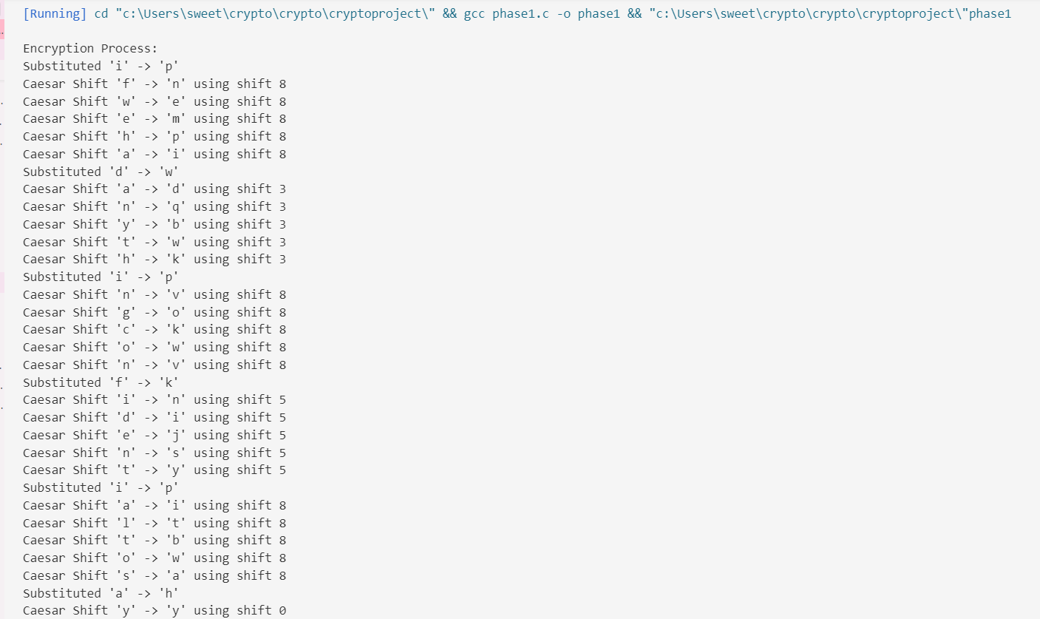
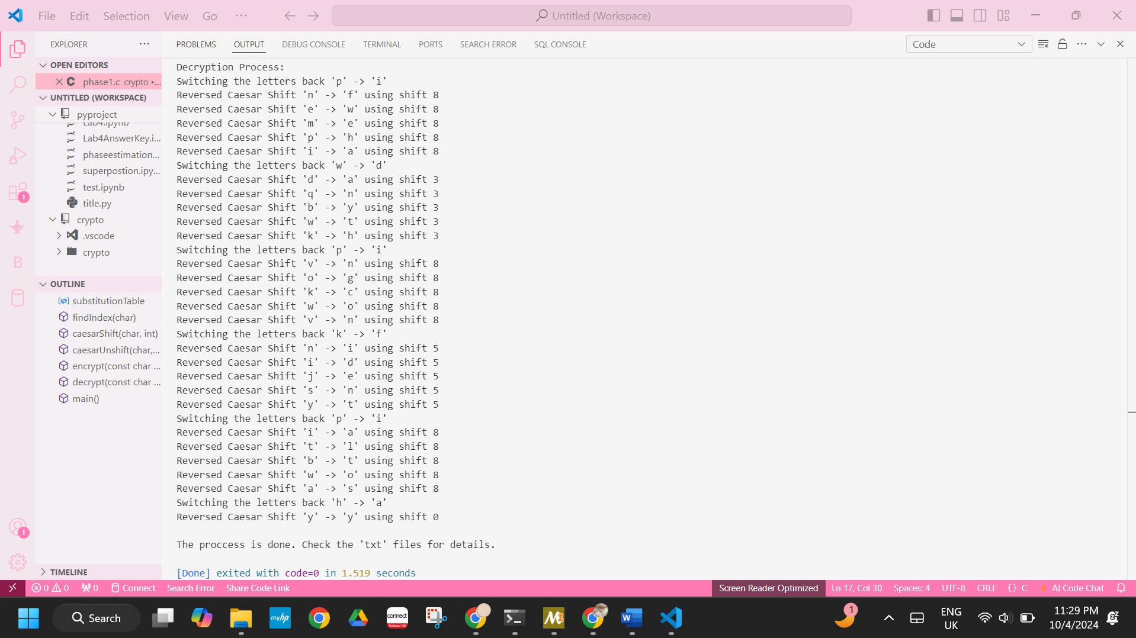
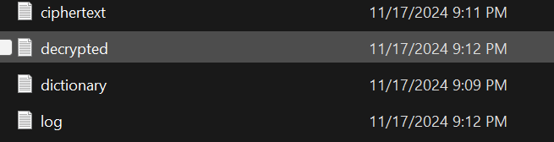

Summary:
This project provides for a hybrid encryption and decryption using a combination of substitution cipher and Caesar cipher. Through a predefined substitution table, every sixth letter of the alphabet is replaced with a plain letter from this specified substitution table. While the remaining letters undergo a Caesar transformation based on the position of the last letter replaced, each transformation step can be recorded by the ciphertext system, and the ciphertext can then be decrypted back to its original form. Files are then used to store the plaintext and ciphertext to record the entire process.

PHASE 2

Introduction

The first of the cryptographic systems that follows the principles are the monoalphabetic ciphers and the Caesar ciphers whose operation lies mainly on the substitution of character for the purpose of hiding the plain text. The first one is the simple one where every of the plaintext letters is replaced by a fixed position letter in the cipher alphabet and the second one is a beast where all the letters of the alphabet are shifted by a certain number of places in order to come with the cipher text. Nevertheless, both of the techniques, as it has been mentioned earlier, have a long history and passed the test of time while being quite efficient at the same time they both can be vulnerable to statistical methods, including for example frequency analysis which belongs to the most powerful categories of cryptanalysis.

Frequency analysis builds on the statistically provable determinable patterns of letters and letter combinations in natural languages like the ‘letter ‘e’ is frequently used than the other letters. This method first formulated by Al-Kindi in ninth century is based on comparing the frequency distribution of the letters of the cipher text with the letters of the plain text language.[4] For instance, In Linguistics, some alphabes like “e”, “a”, “o” are used frequently than the rest and the frequency distribution leads cryptologists to make guesses on plaintext characters based on the ciphertext characters.[5]

More involved approaches include single-letter frequency analysis and diagrams or digraphs (two letters), and a full analysis of trigrams (three letters) and the outcomes at that. These methods prey on the fact that most classical ciphers, especially the monoalphabetic ciphers heavily rely on static substitution or transformation. Experiments show that_moveable’s compositions_, simple polyalphabetic techniques which employ Caesar ciphers and monoalphabets interchangeably, can be easily broken by analyzing multi-character sequences.[6]

Objectives

1- Apply Frequency Analysis:
Do single-letter, diagram and trigram and other statistical analyses on the ciphertext to verify the occurrence of similar statistics in the plaintext.

2- Cryptanalyze Polyalphabetic Techniques:
The paper will evaluate the shift encryption algorithm provided by the monoalphabetic substitution cipher and the Caesar cipher specifically to demonstrate the flaws in this system and how to reverse an encrypted message and derive the original plain-text message.

3- Develop Automated Tools:
Develop scripts that will enable interactive frequency analysis as a way of bettering decryption as well as develop scripts that will enable script based exploration on ciphertext.

4- Word Validation:
The decrypted words have to be checked using an English dictionary in order to enhance the results of cryptanalysis.

5- Improve Encryption Security:
Using myths, recommend changes to the encryption algorithm, in light of the works of etherealists to enhance the algorithm’s security against breakage by frequency analysis.

6- Document Results:
The detailed report should include a summary of methods, results and recommendations made within the cryptanalysis as well as the graphic and log analysis.

Methodology

Encryption Algorithm Overview

The project uses a hard methodology on study and decipher a scheme of monoalphabetic substiution and caesar cipher. The methodlogy is dividid into three phases: included encryption, cryptanalysis through frequency analysis, and valdation.

- Monoalphabetic Substitution:
a table that substituted each letter of the English alphabet by a fixed replacement exists. every sixth character, the letter is replaced according to the table
.
- Caesar Cipher:
The shift vale for this code is obtained by using the index of the last substtuted character from monoalphabetic cipher.

- Process Workflow:
The plaintext is read in discrete units, and these units are character.
blank and other non-alphabetic characters such as, colon, semcolon, and brackets are preserved. The output of each operation is an encrypted text that is stored in ciphertext file besides this, logs of the encryption process are provided in detail.

- Challenges Addressed:
More partcularly, any monalphabtic or caesar cipher alone is relatively easy to break. This hybrid approach is intinded to avoid these vulnerabilities on the basis of facts that conceptal strengths of both types can be used.

Frequency Analysis Techniques

- Single-Letter Frequency Analysis:
Divides the number of occurancing letters in the ciphertext by the entirety of the same to determine their frequencies of occurrence. Compares the results to the usual distribution of letters in the english language for instance ‘e’ stands for the most frequent letter

- Diagram Frequency Analysis (Two-Letter Combinations):
Recognizes and counts two-letter sequences that appear in the ciphertext.

- Trigram Frequency Analysis (Three-Letter Combinations):
Centered on recogntion of triphonic letter groups which are met in the english language most often.

- Word Validation Against Dictionary:
This means when decrypting the text its translated into english and then matched against an english dictionary to comes up with valid words.

- Interactive Tools:
The final idea is to involve users in guding frequency analysis by giving feedback to decrypted texts.

Results and Analysis

Attack on Polyalphabetic Techniques
Unlike the monoalphabetic technique where each letter is substituted with the same letter for every shift, while the polyalphabetic is a technique that the same letter one round it will be a letter, and the other round shift will be another letter. By implementing this technique, we will be creating an secure encryption and decryption communication making thing complicated for the attacker.

Single-Letter Frequency Analysis
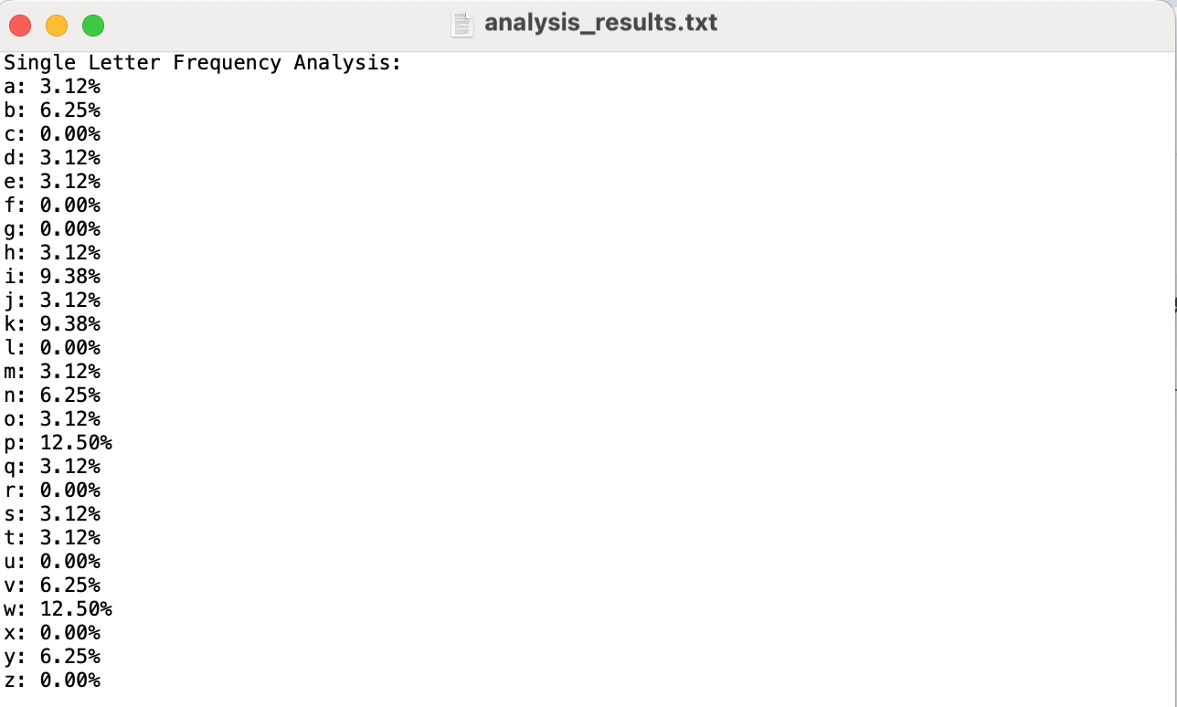

Diagram Frequency Analysis
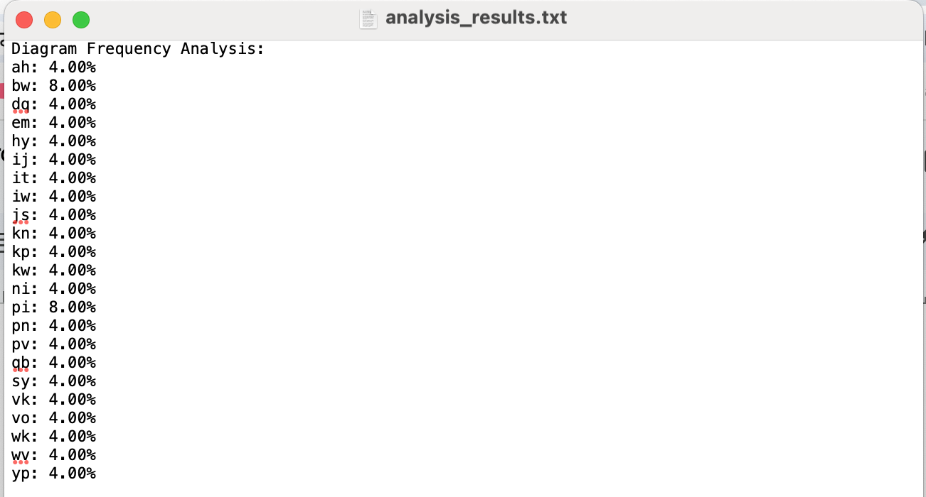

Trigram Frequency Analysis
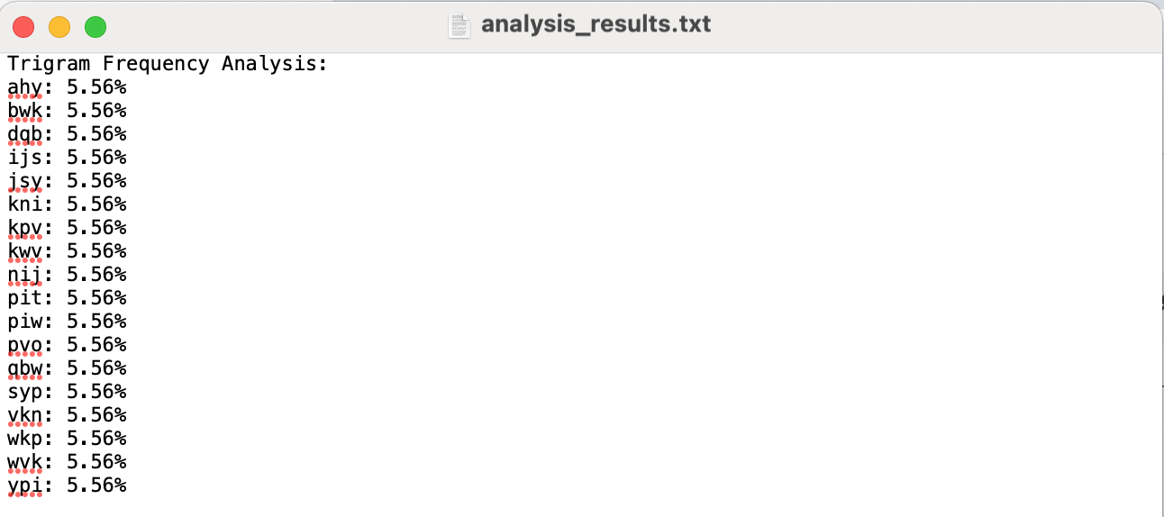

Word Validation
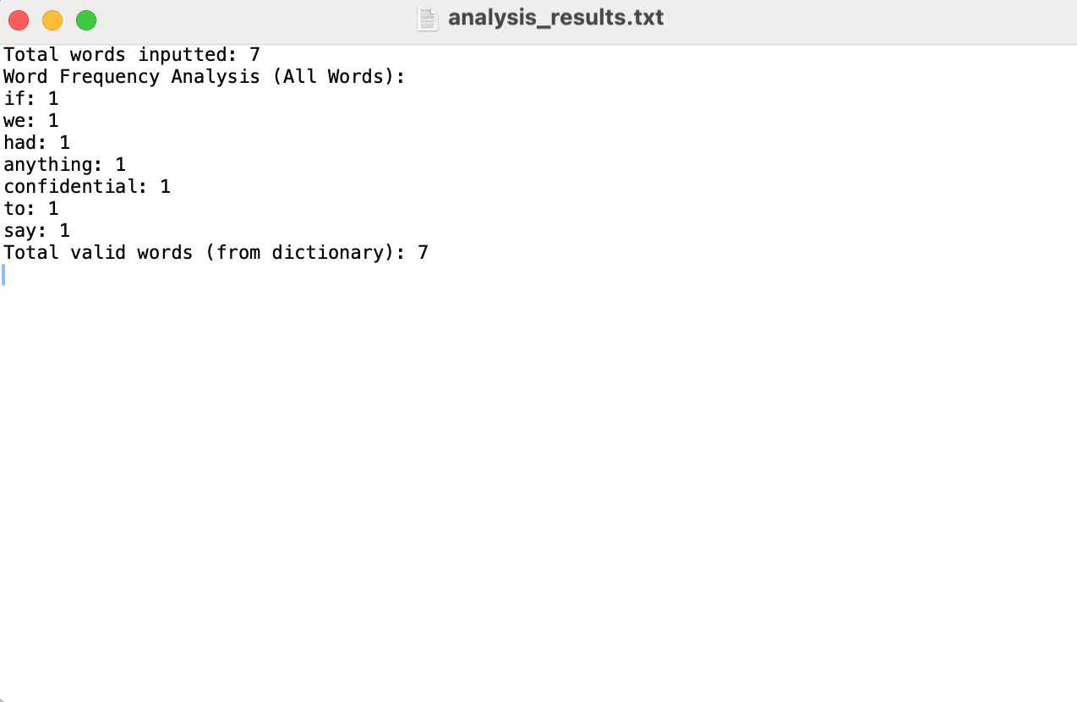

Recommendations for Security Improvement
Firstly, to say the least the current encryption and decryption process has countless weaknesses. We have to address how there is a fixed monoalphabetic table which is subjected to attacks constantly, it involves the use of a very basic caesar shift, with the key itself present in the code, making it extremely difficult to make secure. This also makes it vulnerable to frequency analysis attack and dictionary attack
In order to address all these issues and improve the security , we can choose a much more modern encryption system and one that is not basic such as AES with at least 256bits to add security. Due to the unique nature of AES of multiple rounds, it is resistant to frequency analysis and brute-force attacks, it can make the encryption algorithm stronger and more secure[7]. Also because of efficiency and speed we choose AES rather than RSA which could enhance the security more but however slow down the process , it works better with small data and this will affect our user friendliness, it also has more resources [8][9] . Moreover, our chosen encryption algorithm (AES) could also use the help of hashing for the use of integrity as our additional security services.AES helps in hiding patterns so it is difficult to exploit by an attacker. However in order to improve and double the security of AES, we can still make use of RSA for the key distribution, making it a hybrid cryptographic system.

Conclusion

After analysing the encryption system that put together the use of both mono-alphabetic substitution and Caesar cipher techniques, we understood and saw the vulnerabilities that are present in classical encryption methods through hands-on frequency analysis in phase 2 and also understood basic ecryption and decryption in phase 1. With the help of the dictionary we where able to generate a successful and functional user interface that recognizes cryptanalysis methods from Single letter frequency analysis, diagram and trigram pattern recognition to dictionary-based validation. We were also able to identity the weaknesses in the encryption systems proposed to make use of AES as our secure encryption algorithm to improve security based on discovered vulnerabilities.

Appendix:
#include <stdio.h>
#include <stdlib.h>
#include <string.h>
#include <ctype.h>
#include <sys/stat.h> // For checking if file exists
#include <math.h>
// Substitution table - Mono-alphabetic initial configuration (shared key)
char substitutionTable[26] = {
'h', 'i', 'l', 'w', 'm', 'k', 'b', 'd',
'p', 'c', 'v', 'a', 'z', 'u', 's', 'j',
'g', 'r', 'y', 'n', 'q', 'x', 'o', 'f',
't', 'e'
};
// Constants
#define DICTIONARY_FILE "dictionary.txt"
#define MAX_WORD_LENGTH 50
// Function prototypes
int findIndex(char ch);
char caesarShift(char letter, int shift);
char caesarUnshift(char letter, int shift);
void encrypt(const char *plainText, char *cipherText, FILE *outputFile);
void decrypt(const char *cipherText, char *plainText, FILE *outputFile);
void analyzeSingleLetterFrequency(const char *cipherText, FILE *outputFile);
void analyzeDiagramFrequency(const char *cipherText, FILE *outputFile);
void analyzeTrigramFrequency(const char *cipherText, FILE *outputFile);
void validateWordsAgainstDictionaryFromFile(const char *decryptedFile, const char *dictionaryFile, FILE *outputFile);
void interactiveAnalysis(const char *cipherText, const char *dictionaryFile);
void createBasicDictionary(const char *fileName);
// Create a basic dictionary file
void createBasicDictionary(const char *fileName) {
FILE *file = fopen(fileName, "w");
if (!file) {
perror("Error creating dictionary file");
return;
}
const char *words[] = {
"if", "we", "had", "anything", "confidential", "to", "say",
"hello", "world", "example", "test", "encryption", "decryption", "key", "secure"
};
int wordCount = sizeof(words) / sizeof(words[0]);
for (int i = 0; i < wordCount; i++) {
fprintf(file, "%s\n", words[i]);
}
fclose(file);
printf("dictionary.txt has been created with basic words.\n");
}
// Find the index of a character in the alphabet
int findIndex(char ch) {
if (!isalpha(ch)) return -1;
return tolower(ch) - 'a';
}
// Caesar shift
char caesarShift(char letter, int shift) {
if (!isalpha(letter)) return letter;
char base = islower(letter) ? 'a' : 'A';
return (letter - base + shift) % 26 + base;
}
// Caesar unshift
char caesarUnshift(char letter, int shift) {
if (!isalpha(letter)) return letter;
char base = islower(letter) ? 'a' : 'A';
return (letter - base - shift + 26) % 26 + base;
}
// Encrypt the plain text
void encrypt(const char *plainText, char *cipherText, FILE *outputFile) {
int len = strlen(plainText);
int lastSubstitutionIndex = 0;
int letter_count = 0;
for (int i = 0; i < len; i++) {
if (isalpha(plainText[i])) {
if (letter_count % 6 == 0) {
int index = findIndex(tolower(plainText[i]));
if (index >= 0 && index < 26) {
char substitutedChar = substitutionTable[index];
cipherText[i] = islower(plainText[i]) ? substitutedChar : toupper(substitutedChar);
lastSubstitutionIndex = index;
} else {
cipherText[i] = plainText[i];
}
} else {
int shift = lastSubstitutionIndex;
cipherText[i] = caesarShift(plainText[i], shift);
}
letter_count++;
} else {
cipherText[i] = plainText[i];
}
fprintf(outputFile, "Encrypting: '%c' -> '%c'\n", plainText[i], cipherText[i]);
}
cipherText[len] = '\0';
}
// Decrypt the cipher text
void decrypt(const char *cipherText, char *plainText, FILE *outputFile) {
int len = strlen(cipherText);
int lastSubstitutionIndex = 0;
int letter_count = 0;
for (int i = 0; i < len; i++) {
if (isalpha(cipherText[i])) {
if (letter_count % 6 == 0) {
for (int j = 0; j < 26; j++) {
if (tolower(substitutionTable[j]) == tolower(cipherText[i])) {
char originalChar = 'a' + j;
plainText[i] = islower(cipherText[i]) ? originalChar : toupper(originalChar);
lastSubstitutionIndex = j;
break;
}
}
} else {
int shift = lastSubstitutionIndex;
plainText[i] = caesarUnshift(cipherText[i], shift);
}
letter_count++;
} else {
plainText[i] = cipherText[i];
}
fprintf(outputFile, "Decrypting: '%c' -> '%c'\n", cipherText[i], plainText[i]);
}
plainText[len] = '\0';
}
void analyzeSingleLetterFrequency(const char *cipherText, FILE *outputFile) {
int letterCount[26] = {0};
int totalLetters = 0;
for (int i = 0; cipherText[i] != '\0'; i++) {
if (isalpha(cipherText[i])) {
letterCount[tolower(cipherText[i]) - 'a']++;
totalLetters++;
}
}
fprintf(outputFile, "Single Letter Frequency Analysis:\n");
for (int i = 0; i < 26; i++) {
fprintf(outputFile, "%c: %.2f%%\n", 'a' + i, (letterCount[i] * 100.0) / totalLetters);
}
fprintf(outputFile, "\n");
}
void analyzeDiagramFrequency(const char *cipherText, FILE *outputFile) {
int diagramCount[26][26] = {{0}};
int totalDiagrams = 0;
for (int i = 0; cipherText[i + 1] != '\0'; i++) {
if (isalpha(cipherText[i]) && isalpha(cipherText[i + 1])) {
diagramCount[tolower(cipherText[i]) - 'a'][tolower(cipherText[i + 1]) - 'a']++;
totalDiagrams++;
}
}
fprintf(outputFile, "Diagram Frequency Analysis:\n");
for (int i = 0; i < 26; i++) {
for (int j = 0; j < 26; j++) {
if (diagramCount[i][j] > 0) {
fprintf(outputFile, "%c%c: %.2f%%\n", 'a' + i, 'a' + j, (diagramCount[i][j] * 100.0) / totalDiagrams);
}
}
}
fprintf(outputFile, "\n");
}
void analyzeTrigramFrequency(const char *cipherText, FILE *outputFile) {
int trigramCount[26][26][26] = {{{0}}};
int totalTrigrams = 0;
for (int i = 0; cipherText[i + 2] != '\0'; i++) {
if (isalpha(cipherText[i]) && isalpha(cipherText[i + 1]) && isalpha(cipherText[i + 2])) {
trigramCount[tolower(cipherText[i]) - 'a']
[tolower(cipherText[i + 1]) - 'a']
[tolower(cipherText[i + 2]) - 'a']++;
totalTrigrams++;
}
}
fprintf(outputFile, "Trigram Frequency Analysis:\n");
for (int i = 0; i < 26; i++) {
for (int j = 0; j < 26; j++) {
for (int k = 0; k < 26; k++) {
if (trigramCount[i][j][k] > 0) {
fprintf(outputFile, "%c%c%c: %.2f%%\n", 'a' + i, 'a' + j, 'a' + k,
(trigramCount[i][j][k] * 100.0) / totalTrigrams);
}
}
}
}
fprintf(outputFile, "\n");
}
// Word validation from decrypted.txt
void validateWordsAgainstDictionaryFromFile(const char *decryptedFile, const char *dictionaryFile, FILE *outputFile) {
FILE *dict = fopen(dictionaryFile, "r");
if (!dict) {
fprintf(stderr, "Error: Cannot open dictionary file.\n");
return;
}
FILE *decryptedTextFile = fopen(decryptedFile, "r");
if (!decryptedTextFile) {
fprintf(stderr, "Error: Cannot open decrypted text file.\n");
fclose(dict);
return;
}
// A structure to store words and their frequency
typedef struct {
char word[MAX_WORD_LENGTH];
int frequency;
} WordFrequency;
WordFrequency wordFreq[1000]; // Adjust size based on expected unique words
int uniqueWordCount = 0;
int totalWordCount = 0;
char word[MAX_WORD_LENGTH];
char line[1000];
while (fgets(line, sizeof(line), decryptedTextFile)) {
line[strcspn(line, "\n")] = '\0'; // Remove newline character
char *token = strtok(line, " ");
while (token != NULL) {
totalWordCount++; // Increment total word count for every token
// Increment frequency if word already exists in wordFreq
int found = 0;
for (int i = 0; i < uniqueWordCount; i++) {
if (strcasecmp(wordFreq[i].word, token) == 0) {
wordFreq[i].frequency++;
found = 1;
break;
}
}
// Add new word to wordFreq if not found
if (!found && uniqueWordCount < 1000) {
strcpy(wordFreq[uniqueWordCount].word, token);
wordFreq[uniqueWordCount].frequency = 1;
uniqueWordCount++;
}
token = strtok(NULL, " ");
}
}
fprintf(outputFile, "Total words inputted: %d\n", totalWordCount);
fprintf(outputFile, "Word Frequency Analysis (All Words):\n");
for (int i = 0; i < uniqueWordCount; i++) {
fprintf(outputFile, "%s: %d\n", wordFreq[i].word, wordFreq[i].frequency);
}
// Check for valid words in dictionary
rewind(dict);
int validWordCount = 0;
for (int i = 0; i < uniqueWordCount; i++) {
rewind(dict); // Reset dictionary file pointer
while (fscanf(dict, "%s", word) == 1) {
if (strcasecmp(wordFreq[i].word, word) == 0) {
validWordCount += wordFreq[i].frequency; // Add occurrences of the valid word
break;
}
}
}
fprintf(outputFile, "Total valid words (from dictionary): %d\n", validWordCount);
fclose(decryptedTextFile);
fclose(dict);
}
// Interactive analysis
void interactiveAnalysis(const char *cipherText, const char *dictionaryFile) {
FILE *outputFile = fopen("analysis_results.txt", "w");
if (!outputFile) {
fprintf(stderr, "Error: Cannot open analysis_results.txt.\n");
return;
}
printf("Choose analysis type:\n");
printf("1. Single Letter Frequency\n");
printf("2. Diagram Frequency\n");
printf("3. Trigram Frequency\n");
printf("4. Word Validation (from decrypted.txt)\n");
printf("0. Exit\n");
int choice;
scanf("%d", &choice);
switch (choice) {
case 1:
analyzeSingleLetterFrequency(cipherText, outputFile);
break;
case 2:
analyzeDiagramFrequency(cipherText, outputFile);
break;
case 3:
analyzeTrigramFrequency(cipherText, outputFile);
break;
case 4:
printf("\nPerforming word validation from decrypted.txt...\n");
validateWordsAgainstDictionaryFromFile("decrypted.txt", dictionaryFile, outputFile);
break;
case 0:
fclose(outputFile);
return;
default:
printf("Invalid choice.\n");
}
fclose(outputFile);
}
int main() {
struct stat buffer;
if (stat(DICTIONARY_FILE, &buffer) != 0) {
printf("dictionary.txt not found. Creating a basic dictionary...\n");
createBasicDictionary(DICTIONARY_FILE);
}
FILE *plainTextFile, *cipherTextFile, *decryptedTextFile, *logFile;
char *plainText = NULL, *cipherText = NULL, *decryptedText = NULL;
size_t bufsize = 0;
int choice;
while (1) {
printf("\nMenu:\n");
printf("1. Enter text and save to plaintext.txt\n");
printf("2. Encrypt text from plaintext.txt\n");
printf("3. Decrypt text from ciphertext.txt\n");
printf("4. Perform Frequency Analysis (Phase 2)\n");
printf("0. Exit\n");
printf("Enter your choice: ");
scanf("%d", &choice);
getchar();
switch (choice) {
case 1:
plainTextFile = fopen("plaintext.txt", "w");
if (!plainTextFile) {
perror("Error opening plain text file");
return 1;
}
printf("Enter text to save to plaintext.txt: ");
getline(&plainText, &bufsize, stdin);
fprintf(plainTextFile, "%s", plainText);
fclose(plainTextFile);
printf("Text saved to plaintext.txt\n");
break;
case 2:
plainTextFile = fopen("plaintext.txt", "r");
if (!plainTextFile) {
printf("Error: plaintext.txt does not exist. Please enter text first.\n");
break;
}
fseek(plainTextFile, 0, SEEK_END);
long plaintextSize = ftell(plainTextFile);
fseek(plainTextFile, 0, SEEK_SET);
plainText = (char *)malloc(plaintextSize + 1);
fread(plainText, 1, plaintextSize, plainTextFile);
plainText[plaintextSize] = '\0';
fclose(plainTextFile);
cipherText = (char *)malloc(plaintextSize + 1);
cipherTextFile = fopen("ciphertext.txt", "w");
logFile = fopen("log.txt", "w");
if (!cipherTextFile || !logFile) {
perror("Error opening output files");
return 1;
}
printf("\nEncryption Process:\n");
encrypt(plainText, cipherText, logFile);
fprintf(cipherTextFile, "%s", cipherText);
fclose(cipherTextFile);
fclose(logFile);
free(cipherText);
printf("Encryption complete. Check ciphertext.txt and log.txt for details.\n");
break;
case 3:
cipherTextFile = fopen("ciphertext.txt", "r");
if (!cipherTextFile) {
printf("Error: ciphertext.txt does not exist. Please encrypt text first.\n");
break;
}
fseek(cipherTextFile, 0, SEEK_END);
long cipherTextSize = ftell(cipherTextFile);
fseek(cipherTextFile, 0, SEEK_SET);
cipherText = (char *)malloc(cipherTextSize + 1);
fread(cipherText, 1, cipherTextSize, cipherTextFile);
cipherText[cipherTextSize] = '\0';
fclose(cipherTextFile);
decryptedText = (char *)malloc(cipherTextSize + 1);
decryptedTextFile = fopen("decrypted.txt", "w");
logFile = fopen("log.txt", "a");
if (!decryptedTextFile || !logFile) {
perror("Error opening output files");
return 1;
}
printf("\nDecryption Process:\n");
decrypt(cipherText, decryptedText, logFile);
fprintf(decryptedTextFile, "%s", decryptedText);
fclose(decryptedTextFile);
fclose(logFile);
free(decryptedText);
printf("Decryption complete. Check decrypted.txt and log.txt for details.\n");
break;
case 4:
cipherTextFile = fopen("ciphertext.txt", "r");
if (!cipherTextFile) {
printf("Error: ciphertext.txt does not exist. Please encrypt text first.\n");
break;
}
fseek(cipherTextFile, 0, SEEK_END);
cipherTextSize = ftell(cipherTextFile);
fseek(cipherTextFile, 0, SEEK_SET);
cipherText = (char *)malloc(cipherTextSize + 1);
fread(cipherText, 1, cipherTextSize, cipherTextFile);
cipherText[cipherTextSize] = '\0';
fclose(cipherTextFile);
interactiveAnalysis(cipherText, DICTIONARY_FILE);
free(cipherText);
printf("Frequency analysis complete. Results saved in analysis_results.txt.\n");
break;
case 0:
printf("Exiting program.\n");
free(plainText);
return 0;
default:
printf("Invalid choice. Please try again.\n");
break;
}
}
}

References
[1] | R. Lele, R. Jainani, V. Mikhelkar, A. Nade, and V. Meshram, “The book cipher optimised method to implement encryption and decryption,” International Journal of Scientific & Technology Research, vol. 3, pp. 11–14, 2014.

[2] | X. Zhou and X. Tang, “Research and implementation of RSA algorithm for encryption and decryption,” in Proceedings of 2011 6th International Forum on Strategic Technology, 2011, vol. 2, pp. 1118–1121.

[3] | K. Goyal and S. Kinger, “Modified Caesar cipher for better security enhancement,” International Journal of Computer Applications, vol. 73, pp. 26–31, 2013.
[4] S. Singh, “THE CODE BOOK,” Feb. 2006. [Online]. Available: https://www.math.uci.edu/~brusso/freshman6.pdf

[5] B. Rhodes, “Breaking Encryption: On Deciphering Cryptographic Messages,” Medium, Mar. 30, 2022. [Online]. Available: https://medium.com/tech-is-a-tool/code-breakers-the-war-of-cryptography-1193586528c5

[6] A. J. Menezes, P. C. Van Oorschot, and S. A. Vanstone, “HANDBOOK of APPLIED CRYPTOGRAPHY,” Jun. 1996. [Online]. Available: https://theswissbay.ch/pdf/Gentoomen%20Library/Cryptography/Handbook%20of%20Applied%20Cryptography%20-%20Alfred%20J.%20Menezes.pdf

[7] | P. Kumar and S. B. Rana, “Development of modified AES algorithm for data security,” Optik (Stuttg.), vol. 127, no. 4, pp. 2341–2345, 2016.
[8] | Z. Tuo, “A comparative Analysis of AES and RSA algorithms and their integrated application,” Theoretical and Natural Science, vol. 25, no. 1, pp. 28–35, 2023.
[9] | B. Song, “The AES-RSA hybrid encryption: A balanced approach to secure communication,” Medium, 24-Nov-2023. [Online]. Available: https://medium.com/@bs3440/the-aes-rsa-hybrid-encryption-a-balanced-approach-to-secure-communication-2999e5db596b. [Accessed: 17-Nov-2024].

[10] Sciencedirect.com. [Online]. Available: https://www.sciencedirect.com/topics/computer-science/polyalphabetic-cipher#:~:text=A%20polyalphabetic%20cipher%20uses%20multiple%20alphabets%3A%20%E2%80%9CE%E2%80%9D%20may%20be,of%20English%20letters%20in%20text.
[Accessed: 17-Nov-2024].

